

**Reka Bentuk Antara Muka Berasaskan Web**

**(CSF3133)**

**LAB REPORT 8**

NAME: CHIA FU YAN

MATRIC: S75039

DATE: /12/2024

GROUP: K4

PROGRAM: Computer Science (Software Engineering)

LECTURER: Miss Wan Fatin

**8.3 Create First Web Page with Bootstrap**

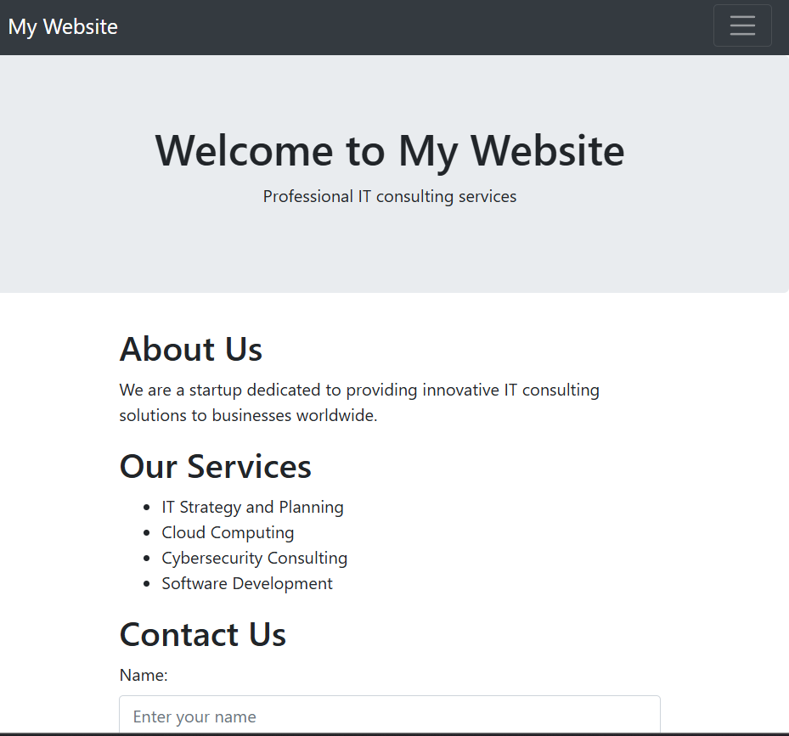

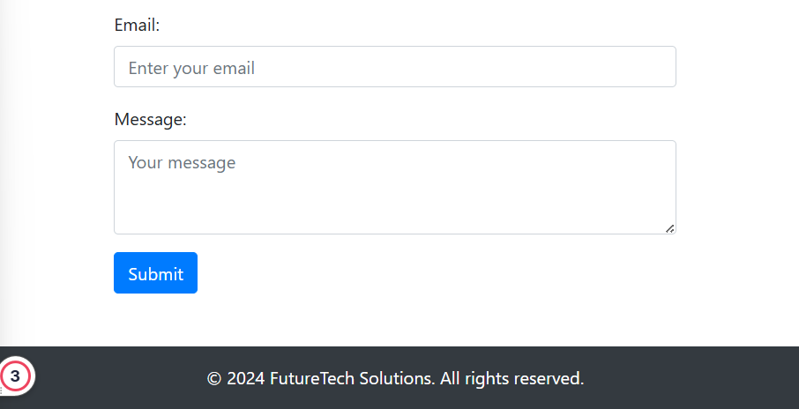

**8.4 Responsive Image**

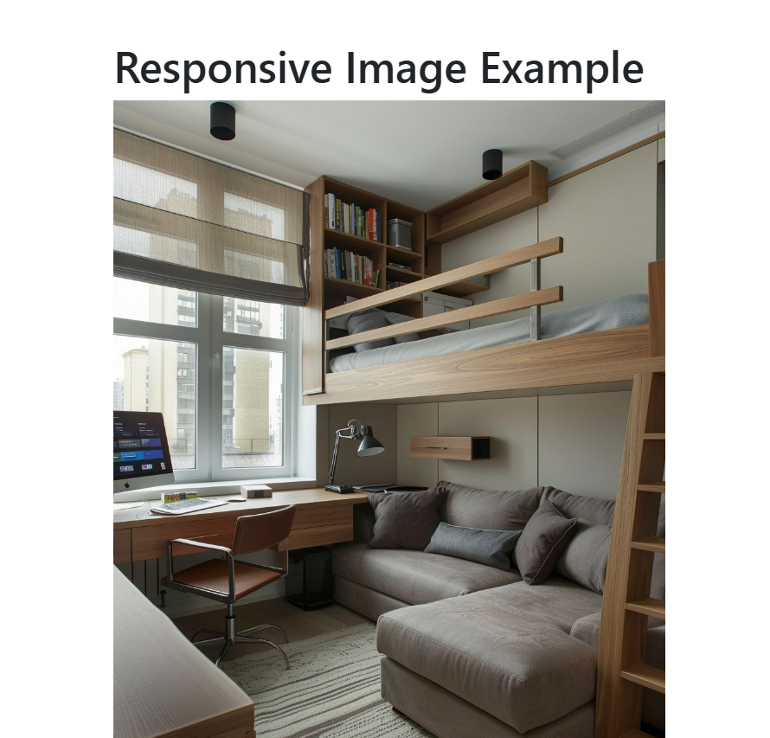

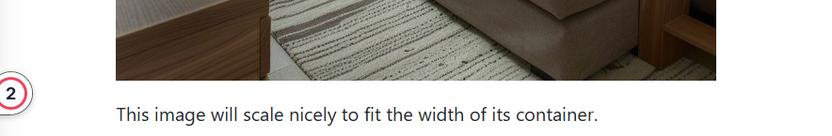

**8.5 Bootstrap Text/Typography**

**8.5.1 Headings**

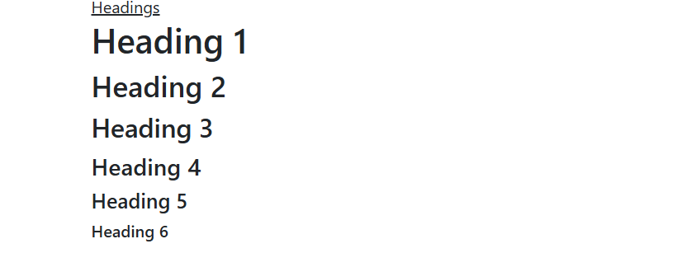

**8.5.2 Display Headings**

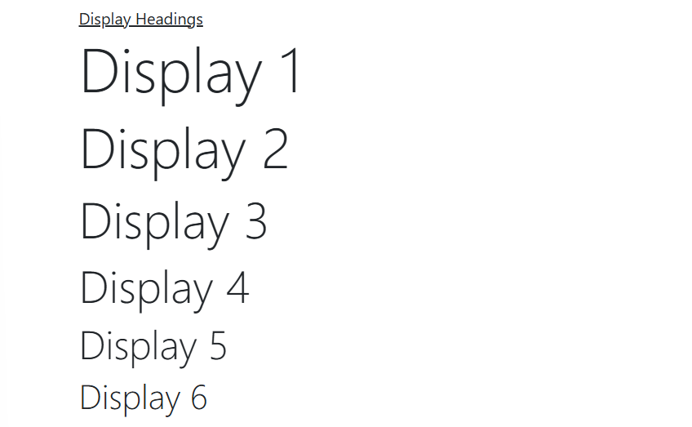

**8.5.3 Inline Text Elements**

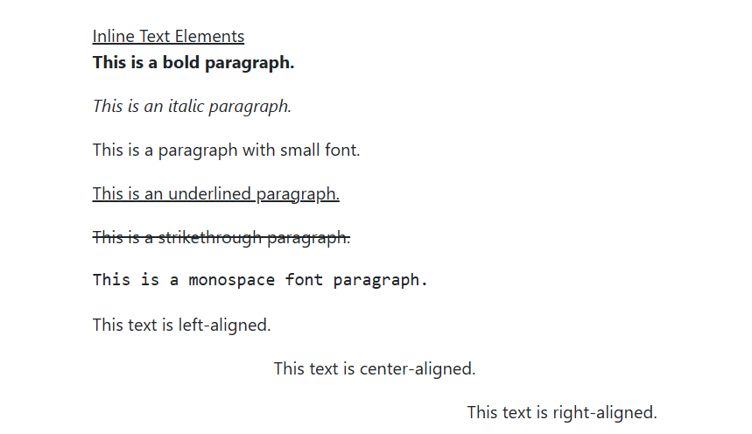

**8.5.4 Text Color and Background**

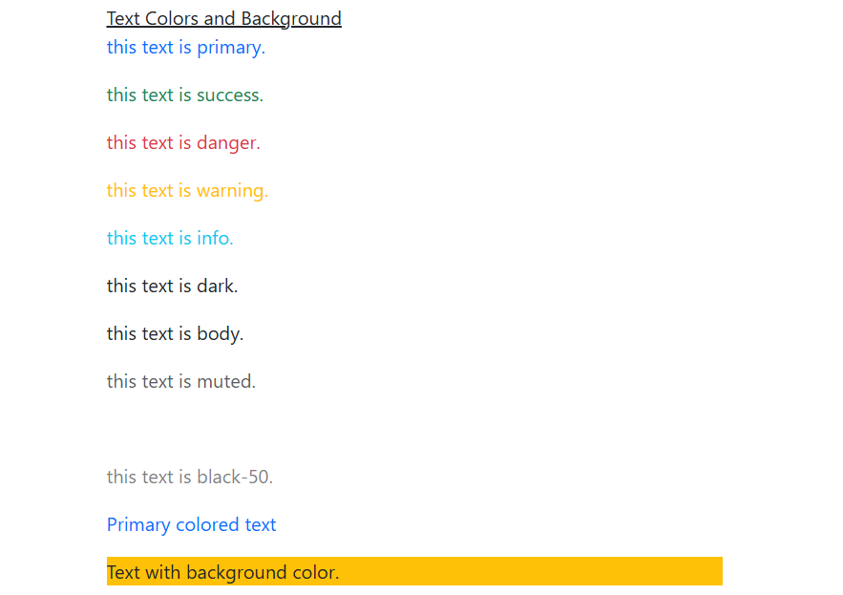

**8.5.5 Text Wrapping and Overflow**

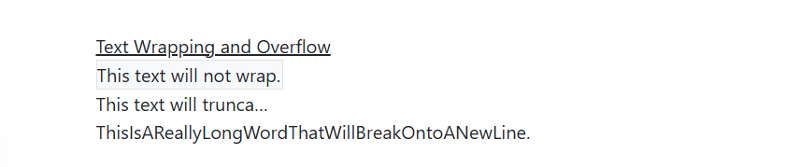

**8.5.6 Font Size**

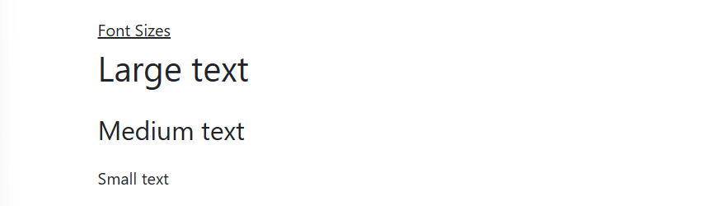

**8.5.7 Font Weight and Style**

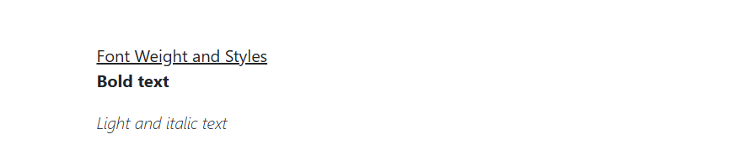

**8.5.8 Line Height**

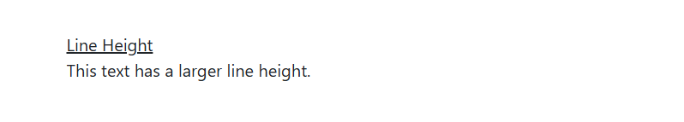

**8.5.9 Lists**

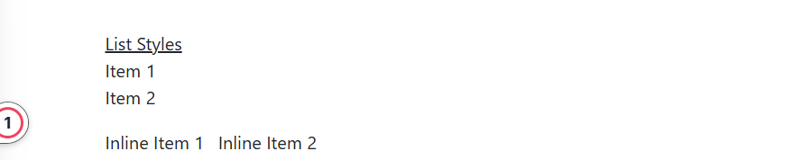

**8.6 Vootstrap CSS Forms**

**8.6.1 Basic Form Structure**

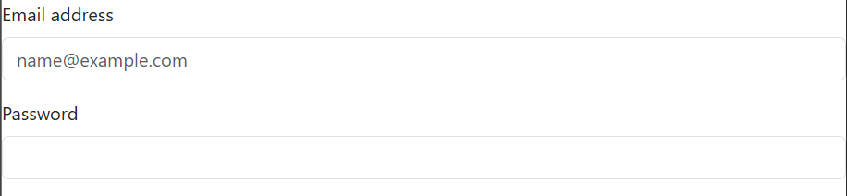

**8.6.2 Form Layouts**

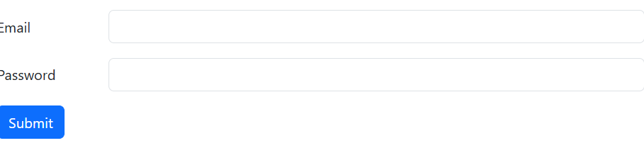

**8.6.3 Inline Forms**



**8.6.4 Form Controls**

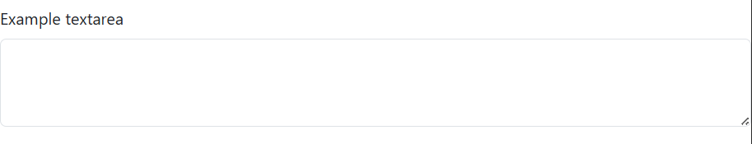

**8.6.5 Select Menus**

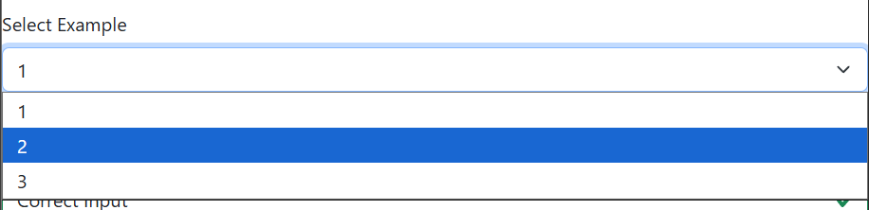

**8.6.6 Form Validation**

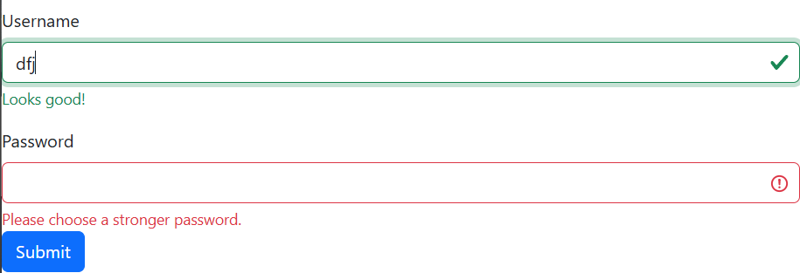

**8.6.7 Checkboxes and Radios**

**Checkboxes**



**Radio Buttons**

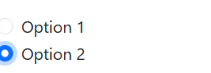

**8.6.8 Input Groups**



**8.6.9 Floating Labels**

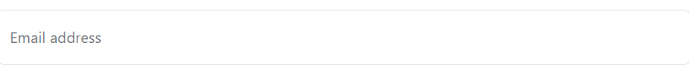

**8.6.10 Disabled and Readonly Inputs**

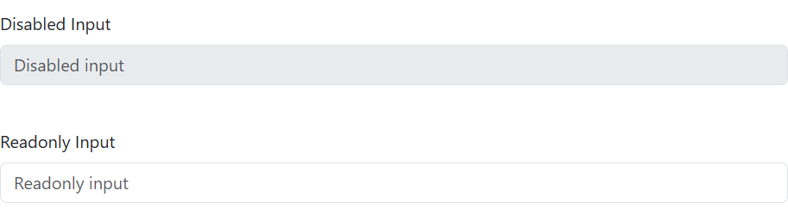

**8.6.11 Example Forms**

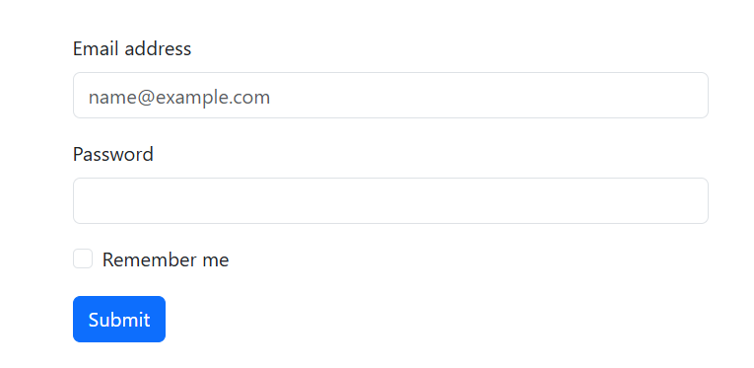

**8.7 Using Bootstrap Theme**

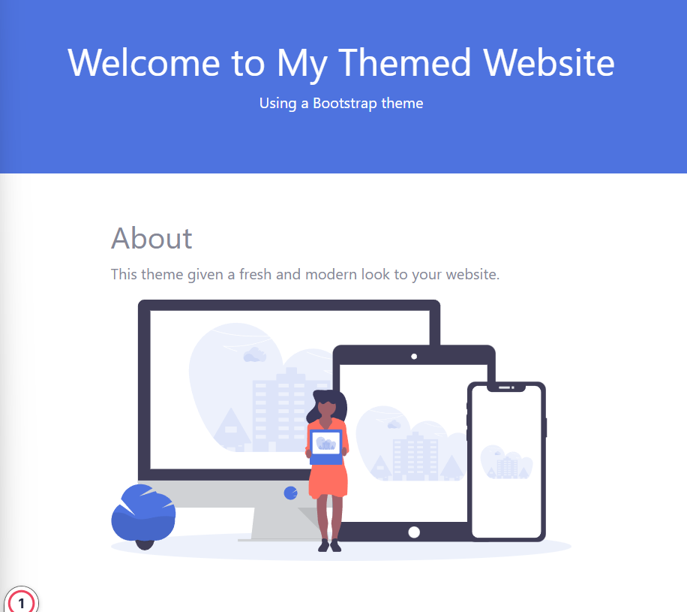

**8.8 Lab Exercise 8**

**Source Code**

home.html

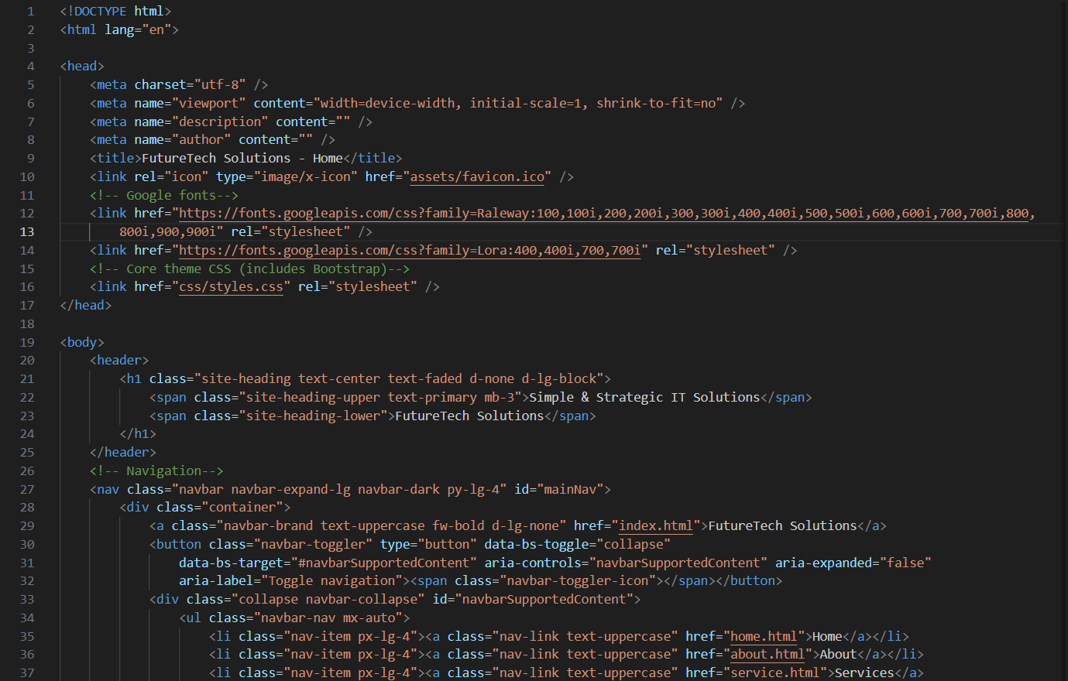

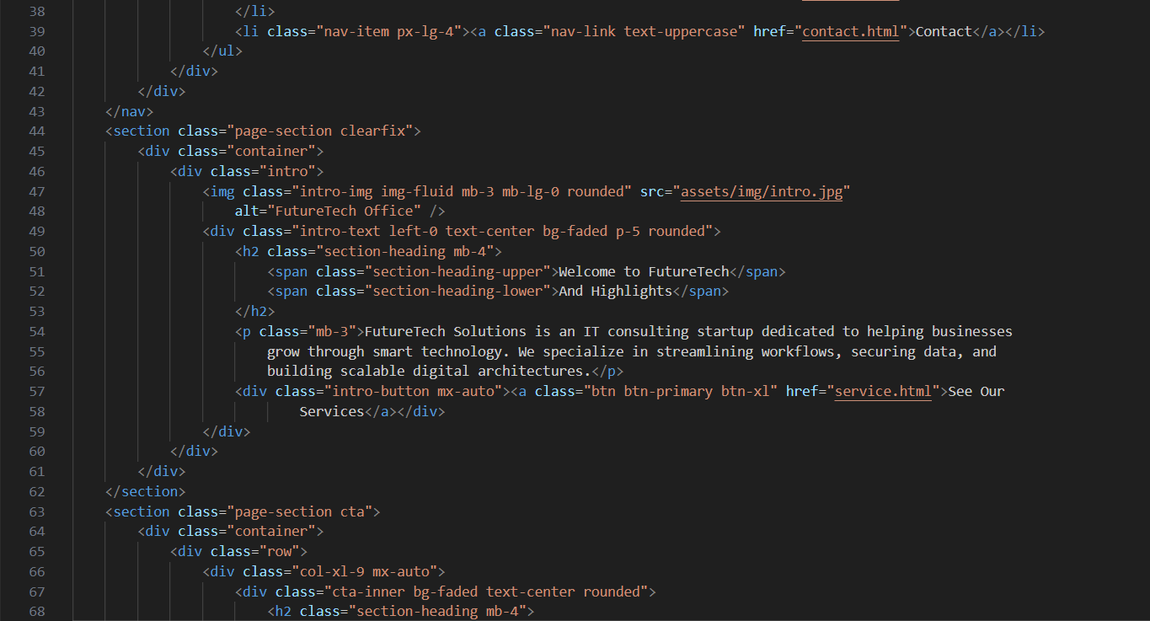

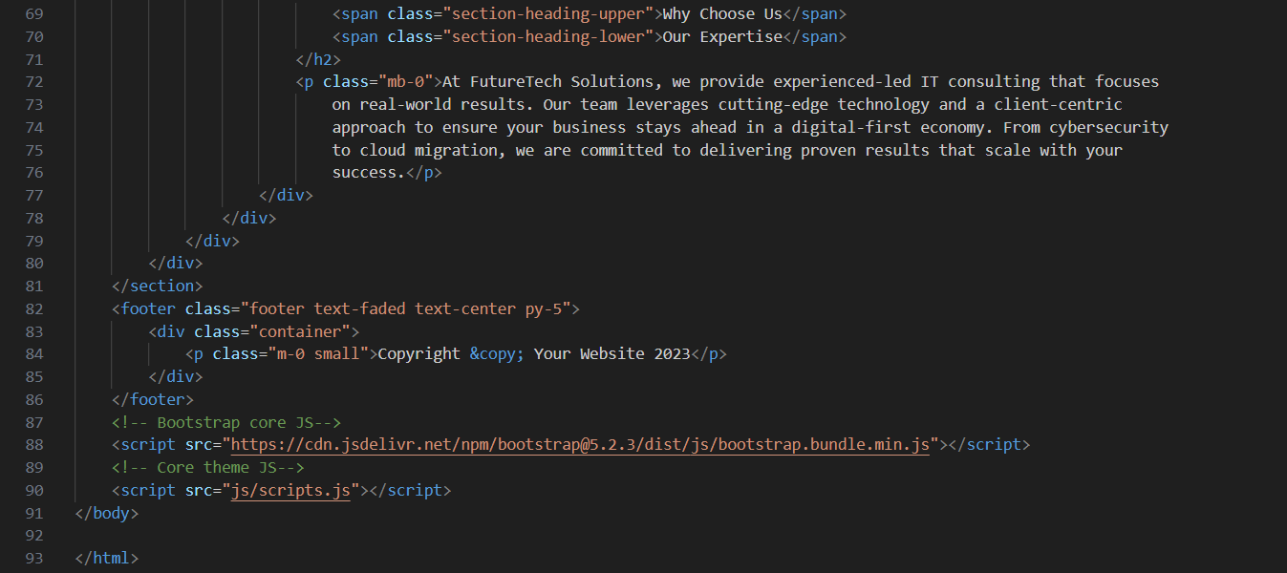

about.html

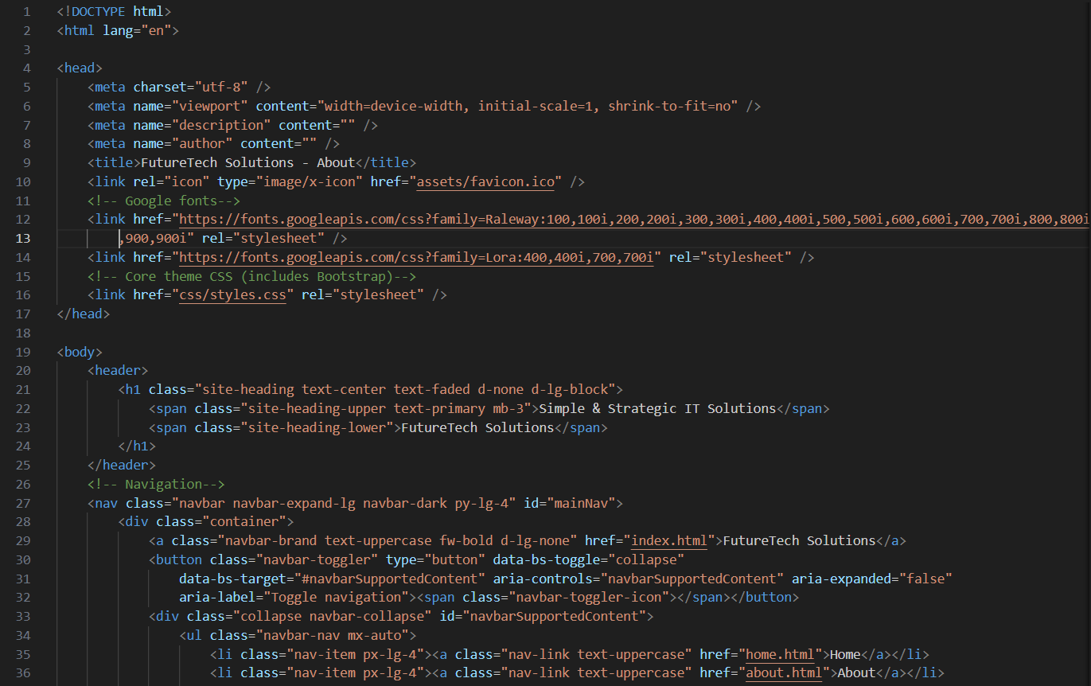

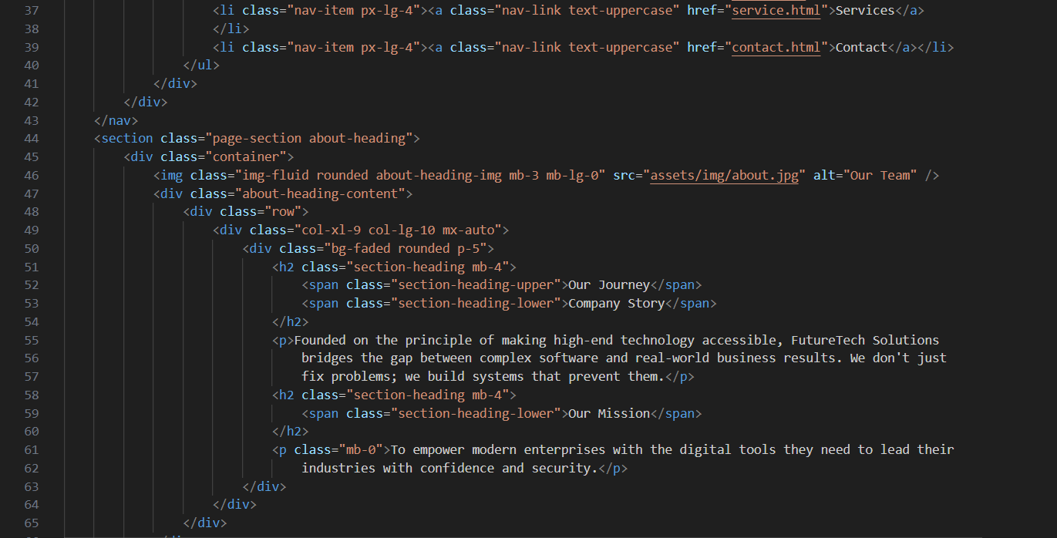

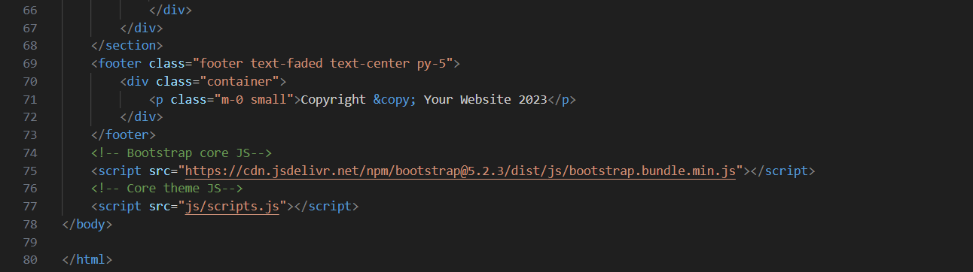

service.html

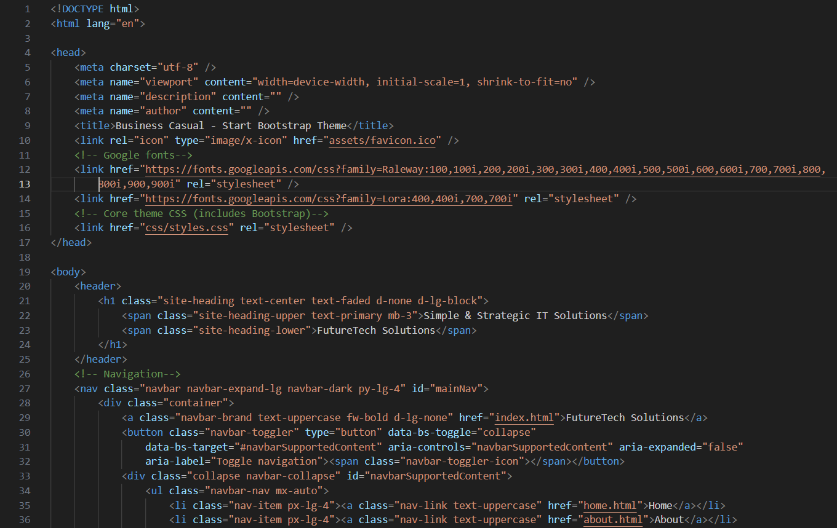

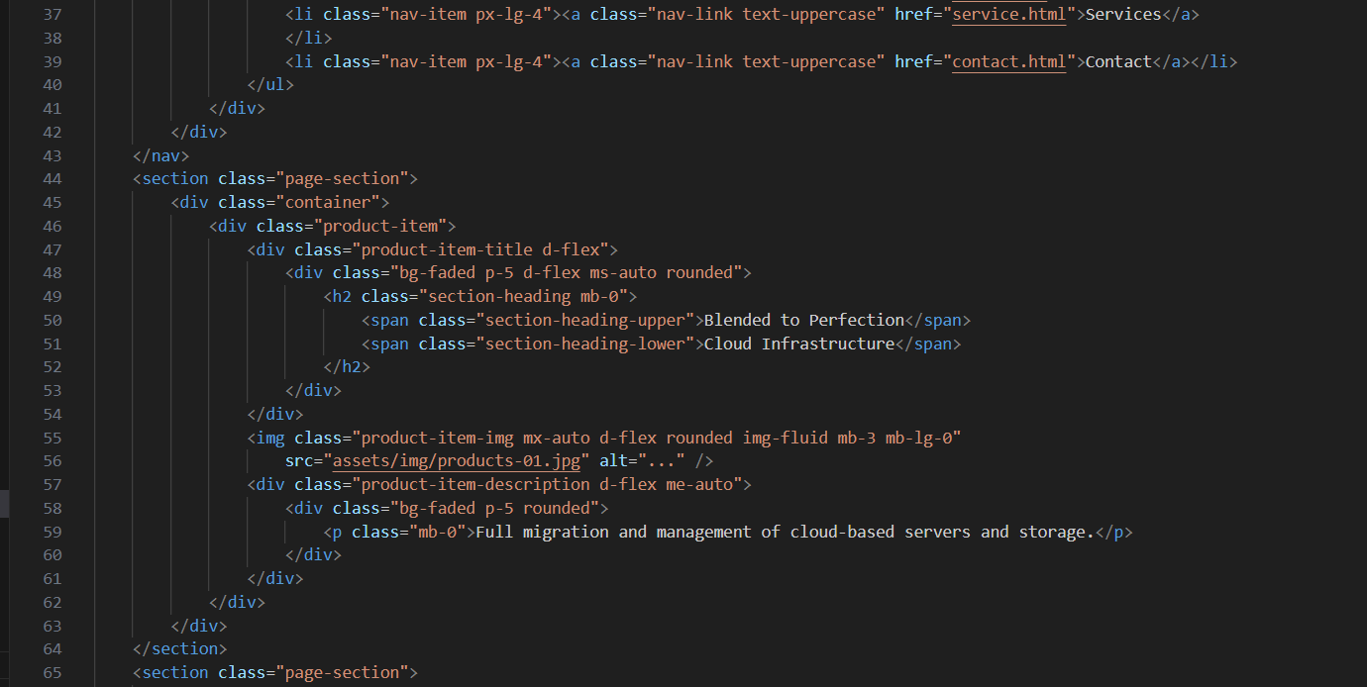

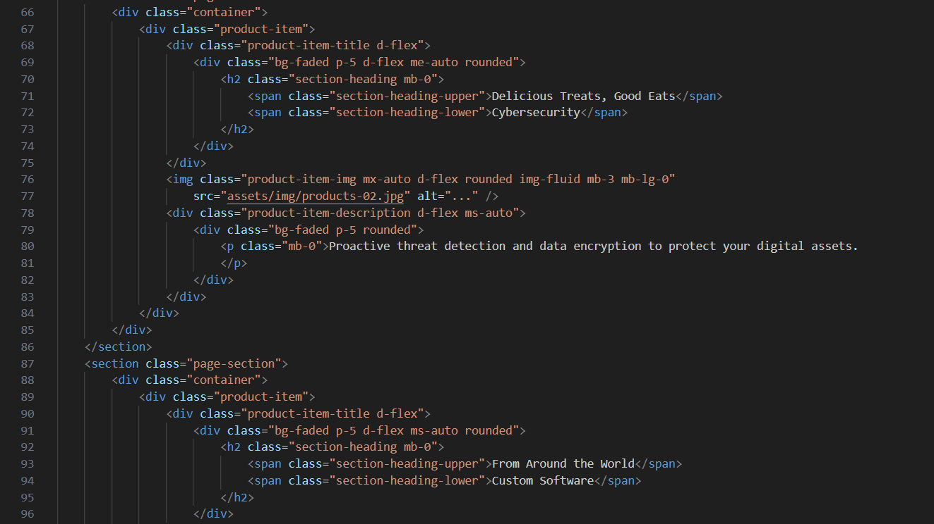

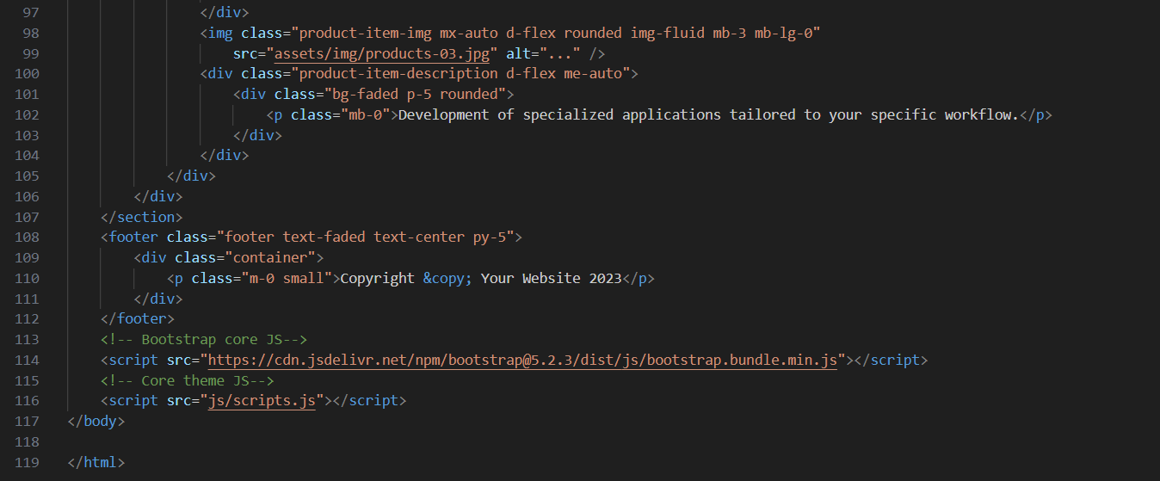

Contact.html

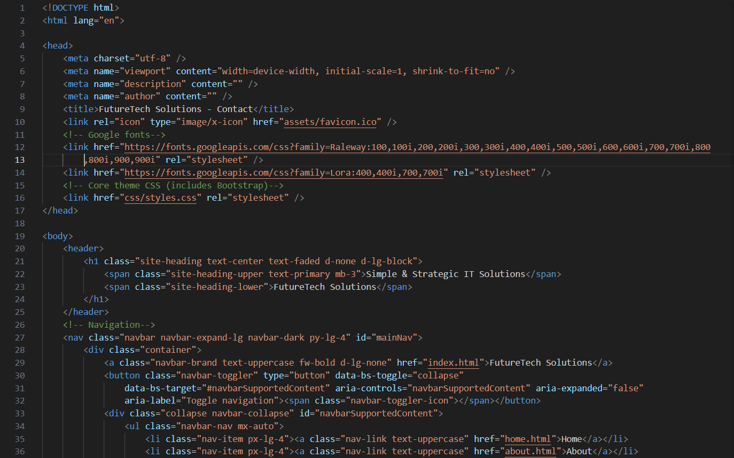

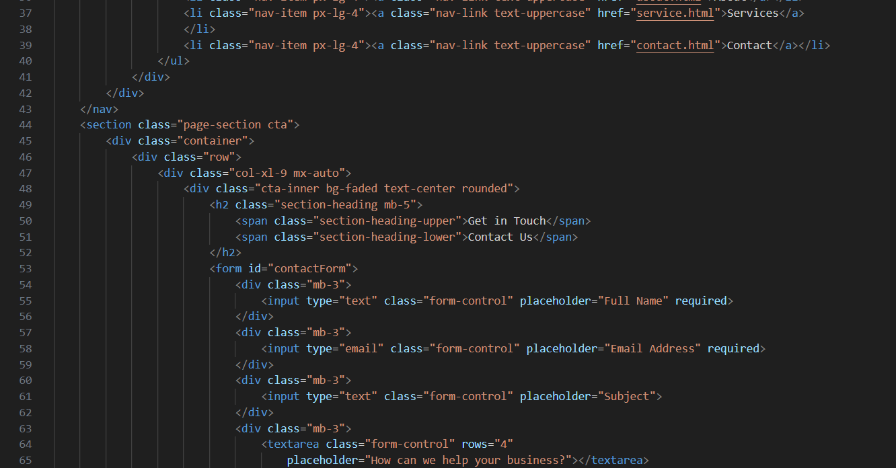

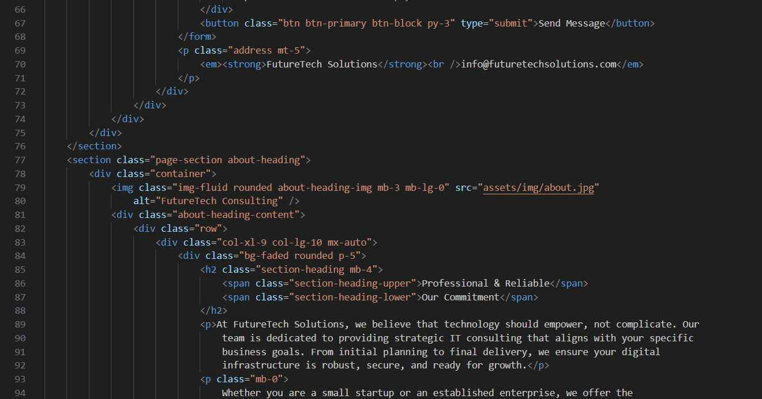

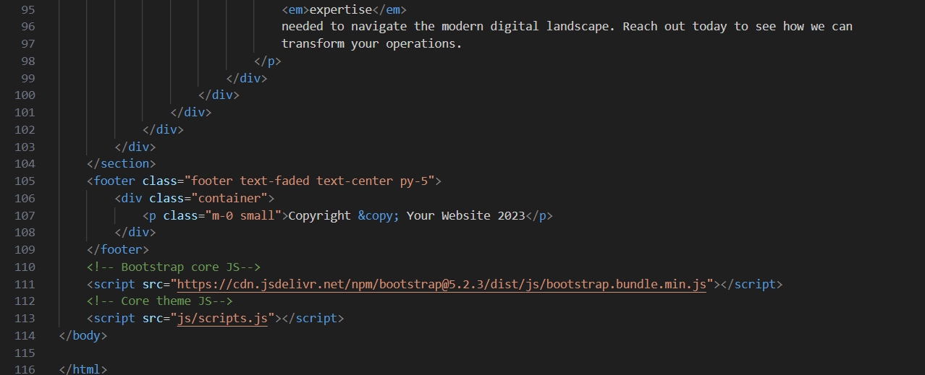

**Output**

**home**





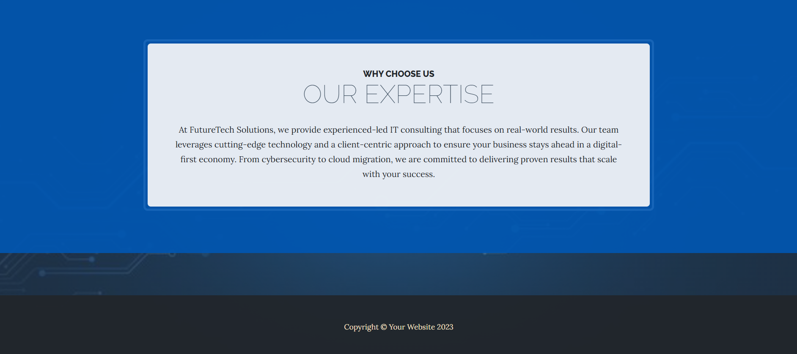

**About**





**Service**









**Contact**

